Objects and Tabs :

Page Layout :

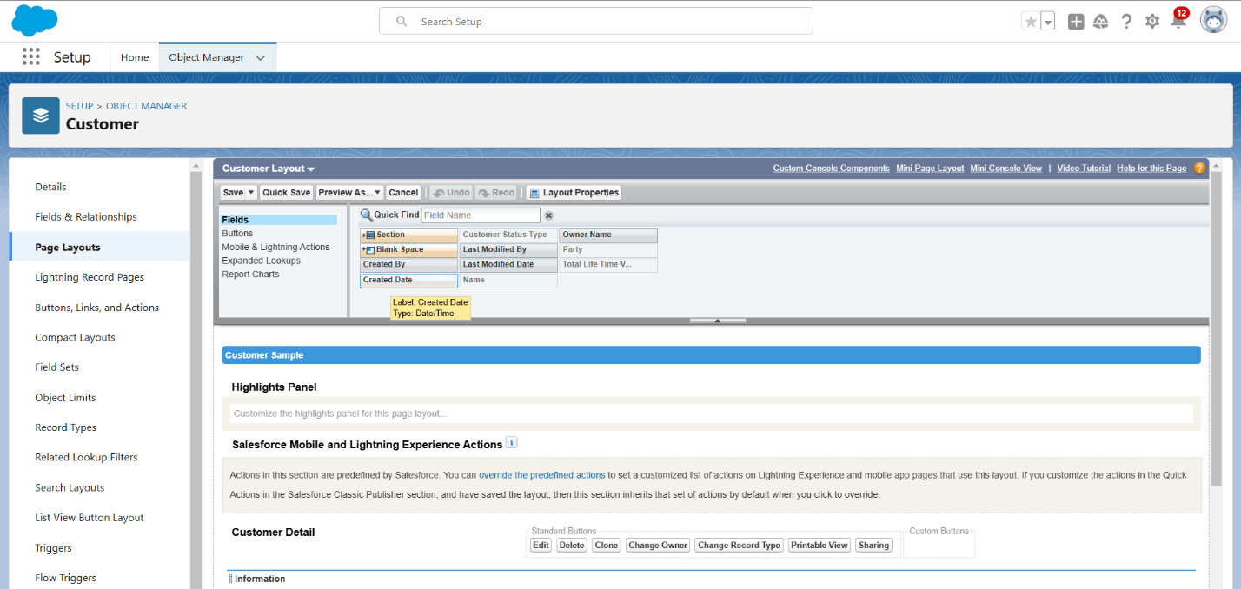

Users Profile :

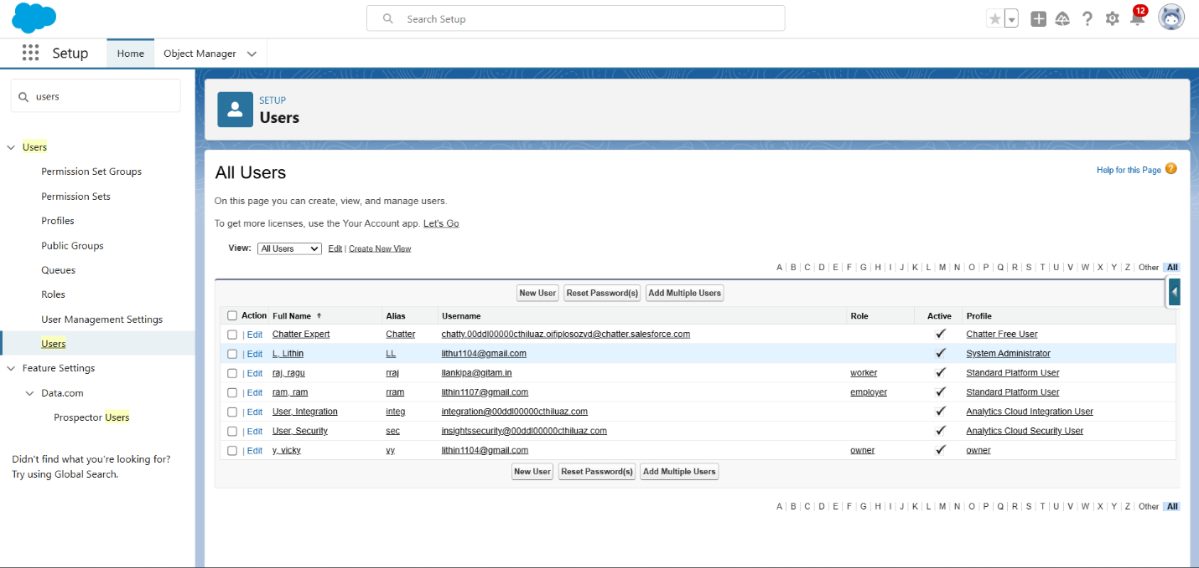

Hierarchy Roles

Validation Rules

Report :

Dashboard :

